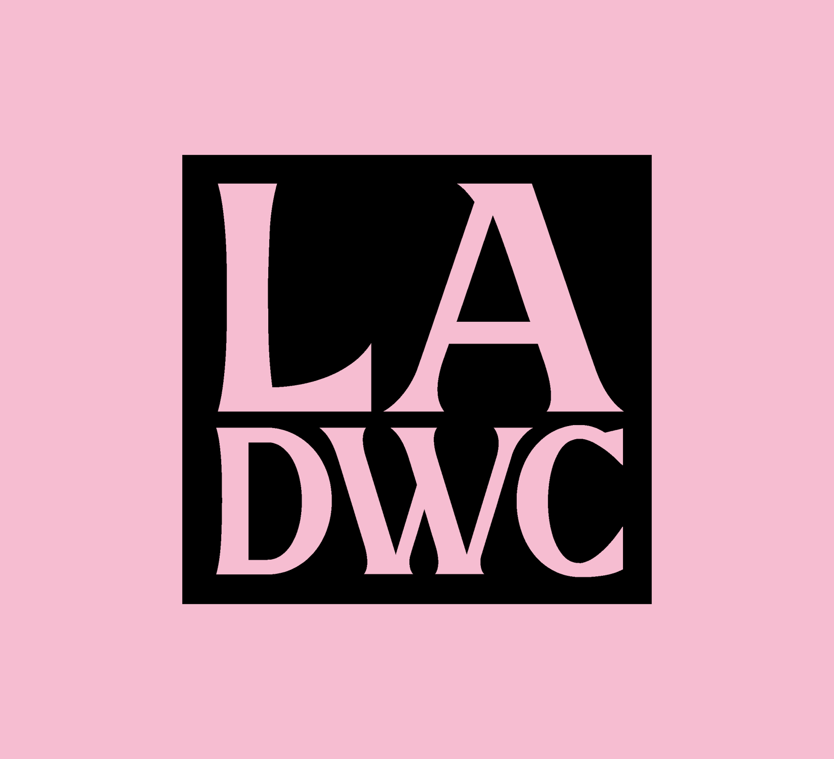

DANCE IN THE DISTRICTS PROGRAM APPLICATION

CONTACT INFO
1. Official IRS Name of Applicant
2. Popular Name if Different
3. Contact Person First Name
4. Contact Person Last Name
5. Applicant's Physical Address Include city, state and zip code
6. Council District 2/3/8/10 Confirmation
Please confirm whether you live and/or work in Council Districts 2, 3, 8 or 10. Adjacent districts will be considered.
Visit https://neighborhoodinfo.lacity.org/ (link will open a new browser tab), enter your home address or place of work’s physical street address in the search field and click on "FIND." In your search result, you should see
your City Council District number and LA City Councilmember's name listed under Elected Officials.
7. Mailing Address If different from above.
8. Phone Number of Contact Person. Enter phone number in this format: (555) 555-5555
9. Email Address of Contact Person
10. Web Address (if applicable)

DEMOGRAPHIC INFO
LADWC and the DCA are committed to equitable access and participation in the process AND distribution of arts resources in service to the diverse cultures of Los Angeles. Any data shared in this section would be used to monitor our progress in achieving this goal. Your responses would remain confidential and be used for internal purposes only.

11. With which gender(s) do you identify? (select any/all that apply)
- Female
- Gender non-conforming
- Non-binary
- Intersex
- Male
- Transgender
- 2S (Two Spirits)
- Prefer not to answer

12. Which pronouns do you prefer?
- he/his
- she/her
- they/them
- Other

13. What is your age?
- 18 to 27
- 28 to 37
- 38 to 47
- 48 to 57
- 58+
- Prefer not to answer

14. With which ethnic heritage do you identify? (select any/all that apply)
- Arab
- Arab American
- Middle Eastern
- North African
- Asian
- Asian American
- Asian Indian
- Indian American
- African
- African American
- BlackIndigenous
- Native Alaskan
- Native American
- Latin American
- Latino/Latina/Latinx
- Native Hawaiian
- Pacific Islander
- White
- Prefer not to answer

15. Do you identify as a person with a disability?
- Yes
- No
- Prefer not to answer

APPLICANT INFORMATION
16. Do you have full time employment?
17. How long have you lived in Los Angeles?
18. What percentage of your total income comes from dance?
19. Define how you get paid
- W-9
- Unemployment
- 1099 (w/ detail)
20. Have you received unemployment since March 2020?
21. What is your Household size?
22. Do you have dependents? If so, how many?
23. Considering the broader picture, how were you (personally) impacted by Covid-19? (250 word limit)
24. My dance career has been impacted by the pandemic in the following ways (check off all that apply):
- studio closures;
- touring canceled;
- layoffs or loss of work;
- staff reduction;
- hours reduction;
- lack of public funding;
- other_____

25. Statement of Need: What are your immediate needs (Examples: Technology, Transportation, Medical, Practice - be specific)(250 word limit)

ARTISTIC PRACTICE
26. Please provide a brief bio about your practice. (300 word limit)
27. Define their dance work type
- West African
- Polynesian
- Folklorico
- House/Hip-Hop
- Classical Cambodian
- Bharata Natyam
- Classical Thai
- Classical Korean
- Afro-Brazilian
- Social dances
- Native/Tribal
- Ballet
- Modern
- Jazz

28. Briefly describe the online project you propose to produce with Dance in the Districts funding. Please include the prospective number of collaborators you will engage (extras, videographer, music contributor, etc.) (250 word limit) (see guidelines)

ATTACHMENTS
29. Portfolio
- CV
- Provide at least two weblinks to video or other material, such as YouTube, Vimeo, event flyer, Facebook event URL, program/event documentation, etc. These two examples should represent the quality of past work as well as the style of the proposed project. (Video limit 3 min). If a video link is submitted, please provide the time section to review.

IMPORTANT NOTE:
You will be asked to provide metrics from your event, including the number of performers, staff and audience; as well as proof of performance such as photos, social media posts, programs, etc.

The 2022 schedule is as follows:
Friday, March 11 – Call for Applicants
Friday, April 22 – Applications due
Friday, June 17 – Awardees Announced
Friday, June 24 – Projects Begin
Friday, July 29 – Projects completed

30. CERTIFICATION STATEMENT

The undersigned hereby certifies that the statements and information set forth above and/or annexed to this application are true to the best of his or her knowledge and that the materials submitted in support of this application represent the applicant's own work. It is understood and agreed to by the undersigned that the Department of Cultural Affairs may rely thereon in determining this application for certification, and that the making of any knowingly false statement or fraudulent submission in connection with this application will result, in either the denial thereof or in the revocation of any artist's certification based on such application. I further certify and claim eligibility for this funding opportunity because work or home is headquartered in Council District 2, 3, 8 and 10 of the City of Los Angeles.

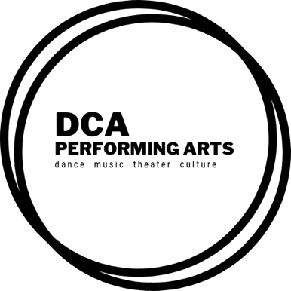
_________________________________________
Signature

_________________________________________
Printed Name

______________________________________
Date

